**Microclimate Monitoring System**

**Abstract**

As changes take place in the global climate, it is important and beneficial to know how those changes may affect various regional microclimates. With this knowledge, plans can be developed to take advantage of those changes as well as try to mitigate any negative effects they may have. To make intelligent decisions, a baseline of microclimate data must be developed. The stakeholder, the NYSDEC, has commissioned the development of data collection for this baseline with particular focus on its own various microclimates. There was found to be a scarcity of data about baseline soil conditions; so, the particular focus of this project is to collect contributive data concerning soil conditions within these microclimates.

**1. The Problem**

**a. Problem Statement**

The New York State Department of Environmental Conservation (NYSDEC) needs a better understanding of the possible impact of global changes in the climate on the microclimates within New York State so that appropriate plans may be developed to both take advantage of the positive effects and mitigate any adverse effects.

**b. Problem Introduction**

To better understand the possible effects of changes in the global climate on the various microclimates of New York State, the NYSDEC needs to create a comparative baseline from which to analyze any changes. To build this baseline, an array of sensors will be deployed throughout the state to collect environmental data. It is intended that this data will be open and free to the public and that, when analyzed, may be used to influence a wide variety of decisions across a wide variety of sectors. The collected data will reveal any trending changes in microclimates so that these decisions may be informed and intelligent. For example, a person or industry may choose to invest in a certain type of real-estate project depending on this data. Also, certain wildlife behaviors may be better predicted and accommodated, and people may make informed decisions about where they may want to retire. The desire is to connect how climate changes in other regions of the globe affect or do not affect the various microclimates of New York State.

As an example, recall the recent major wildfires in Canada (2023) and the short-term/seasonal effect they had on our own region. As that initial effect has settled, it is important to know if there have been any longer-term effects. Knowing how changes in the climate of other global regions affect or do not affect the microclimates of New York State will be helpful in developing proper responses. At the moment, however, there is no baseline with which to make comparisons, and decisions are being made based upon subjective speculation.

**2. Inspiration**

There are many factors that contribute to building a baseline that accurately defines a climate (or microclimate). Many of these factors have adequate data. For instance, weather trends and patterns have very good documentation going back for many generations. While researching the possible contributions the team could make to building the baseline, it was discovered that a significant factor that influences the definition of a particular climate is the health and characteristics of the soil (see article “Soil Phenomena…” under Citations). However, it was difficult to find adequate documentation regarding soil conditions of the microclimates of New York. For this reason, the team decided to contribute data regarding soil health and characteristics to the overall NYSDEC project.

There exist several diverse types of soil metric sensors from which we could choose to build our collection device. These include sensors that can collect soil and air temperature, pH levels, ground moisture, sunlight, and iron oxidations, and we have found that many of these devices are compatible with an Arduino device. The collection of pH levels from soil throughout New York’s microclimates, with special attention to the transitions between the microclimates (see “Researchers Create…” article in Citations), was chosen as the metric about which data would be collected to contribute to the NYSDEC project. Through the team’s research, it was found that pH levels are a reliable and stable metric that can be collected over an extended period and characterize soil health quite well (see “Researchers Create…” article in Citations).

By collecting the pH levels from a submerged probe, there is less chance of the sensor being disturbed by wildlife and human interactions. Our system will be using an energy storage system to power the collection device and to transmit data to the technician. It will collect data four times per day, store the data on an integrated storage device, and go into a sleep mode the rest of the time.

**3. System Requirements**

**a. Use Case Diagram**

The use case diagram below shows the actions and functions related to the microclimate monitoring system. In our system, the technician will be responsible for collecting the data from the FSU located in a remote location by taking their laptop computer, with the receiver attached, to the general location of the FSU. Once within range, the technician will initiate the transfer of the stored data from the FSU to their laptop. Once the data is received, the technician will give it a quick check to make sure that the sensor is gathering valid data points and make calibrations to the unit if necessary.

Once collected, the technician will convert the collected data into .csv format, which will then be delivered to the NYSDEC. The NYSDEC will then use this collected data, combined with studies on other climate metrics, to determine the changes in microclimates across New York state.

**Figure 1: Use Case Diagram of the Monitoring System**

**b. Functional Requirements**

* **Environmental Sensing –** The system must accurately measure the soil's pH level in a remote location. The pH level’s accuracy will be decided by assessing the Gravity Analog pH sensor in the pH calibration solutions provided by the manufacturer. Once the sensor is placed in the soil and has had time to adjust to the placement, it will start sending the changes in pH data. The sensor’s accuracy can be affected by the voltage source which will be set at 3.3 volts for maximum accuracy.
* **Collect Data –** The pH level will be collected from the Gravity Analog pH kit connected to the Arduino Uno R3 device. The readings from the pH sensor will be collected four times per day. These times will vary depending on the time of year and location and will be written into the collection algorithm. The collection times will be at sunrise, halfway to sunset, sunset, and halfway to sunrise. The device will be in a sleep mode otherwise.
* **Store Data –** The data will be stored in the internal 2Mbyte SPI Flash drive built into the Arduino MKR WAN 1310 connected to the Arduino UNO R3. The data collected from the pH sensor will be held for one month at a time but will have the storage space for up to two months as a safety measure in case the technician cannot collect the data in the normal collection timeline.
* **Deliver Data –** The data will be transmitted to the receiver using the LoRa communication protocol. The Arduino MKR WAN 1310 has an antenna connected to the device that can send the pH level data to a second MKR WAN 1310 device connected to a PC. The MKR WAN 1310’s antenna will make the unit ready to send data once the technician comes within range with the receiver.
* **Receive Data -** The second MKR WAN 1310 will be used as a receiver connected to the technician’s computer once the technician is within range. This will allow the technician to receive the collected data from the MRK WAN 310’s internal storage and save the data to the technicians’ computer.
* **Analyze Data –** Once the data has been collected, stored, transmitted, and received by the technician, the data can then be analyzed. The pH data that has been collected from the microclimate monitoring system will be entered into Excel so that the raw collected data can be placed into an easy-to-read graph.

**c. Non-Functional Requirements**

* **Replication** – The team task is to build a workable, one-off package that can be clearly and economically replicated by a manufacturer (many of them will be needed for a statewide implementation).
* **Ethical Consideration** – Being a government project, the team will need to consider encroachments and privacy protections when developing strategic placement locations as well as data retrieval methods. Also, the team will need to be sure that any existing market efforts are not challenged.
* **Non-Contamination** – Anything placed in the environment should be neutral and not pose a risk of contaminating the environment or harming animals in case of any animal interactions. For this reason, the unit cannot degrade in the environment.

**d. Design Constraints**

* **Budget** – Our budget is $200.00 for the team. This can be considered a per monitoring unit budget (hardware & software).
* **Time** – Many assumptions had to be made to build out and evaluate a conceptual model in about 2 months.
* **Locations** – This refers to the placement of the monitoring system(s). Being a government owned system, there will be many legal and ethical restrictions upon location options.
* **Data retrieval** – This presents similar legal and ethical restrictions as the location restraint. As a note, the stakeholder will separately consider accumulative data storage and analysis; so, this will only include retrieving and delivering the data to the stakeholder.

**4. System Design**

**a. Design Overview & Justification**

The basic design uses a Field Sensor Unit (FSU) to collect pertinent sensor data from the soil in different microclimates of NYS. A technician will install many FSUs, dispersed throughout the microclimates of NYS. At regular intervals, the technician will collect all the data from the FSUs. The technician will then check the data for anomalies and check the health of each FSU. The technician will omit anomalous data points (attributed to malfunctions) from the NYSDEC report. After checking the quality of the data, the technician will format it according to the desires of the stakeholder and, finally, deliver it to the stakeholder.

An alternative design was to collect data concerning weather metrics, but there was found to be saturation in this field already, and little collection of data about soil metrics, which, after researching the goal of detecting changes in a microclimate (see “Soil Phenomena…” article in Citations), was found to provide more relevant and actionable information. We also briefly explored the idea of a system based on home units kept by citizens of NYS and connected to their home electronics. In considering this system, we met many ethical issues related to government restrictions as well as being able to keep professionally controllable data collection.

|  |  |  |  |  |  |  |  |
| --- | --- | --- | --- | --- | --- | --- | --- |
| Decision Matrix | | | | | | | |
| Criteria | | Options | | | | | |
| Desc. | Weight | Technician Weather | | Technician Soil | | Home Weather | |
| Score | Weighted  Score | Score | Weighted Score | Score | Weighted Score |
| Cost | 1 | 2 | 2 | 2 | 2 | 4 | 4 |
| Data  Integrity | 2 | 4 | 8 | 4 | 8 | 2 | 4 |
| Simplicity | 1 | 4 | 4 | 4 | 4 | 3 | 3 |
| Relevancy | 2 | 2 | 4 | 4 | 8 | 2 | 4 |
| Total | |  | 18 |  | 22 |  | 15 |

**Table 1: Decision Matrix of Alternative System Designs**

Decision Matrix Notes:

* + Cost: A high score here correlates to a lower cost. The technician model would have a more professional quality and, thus, cost more. These units must be able to stand up to a wide variety of weather elements and last in the field for an extended period without having to be replaced.
  + Data Integrity: This refers to the ability to control the conditions of data collection, with uniformity being a higher value and variability being a lower value. There needs to be accurate data that is resistant to anomalies so that the NYDEC can study these results over an extended period.
  + Simplicity: This refers to design, with a special emphasis on utility (a higher score) over aesthetics (a lower score). As the home unit would require a more stylish interface, it received a lower score here.
  + Relevancy: This had specifically to do with achieving the desire of the stakeholder, which is to build a baseline of reliable microclimate characteristics that are not already commonly measured. Also, it was found that soil monitoring may provide better metrics for discovering the effects of changes in the climate.

**b. Black Box Diagram**

The input of the black box system is the type of metric that will be measured, soil pH, and the output is the type of output that is required by the stakeholder, a .csv file.

**Figure 3: Black Box Diagram of the Monitoring SystemFigure 2: Black Box Diagram of the Monitoring System**

**c. Logical Design**

The logical design that has been developed has been built to collect the pH readings from the soil, transfer the readings to the storage device and then transmit the data to the receiver. In the diagram below, we show how the unit will be powered from a source provided by another group connected to our FSU. The FSU will then collect the data at the assigned intervals, store the readings inside the unit and then transmit the data once the receiving unit is within range. The receiving unit will be able to display the readings along with a date and time so that the technician can be sure the unit is working the way it is supposed to be.

**Figure 3: Logical Design of the Monitoring System**

**d. Wireframe Model**

The wireframe diagram below shows the expanded view of the user interface for this system. Through the ARDUNIO IDE, the date, time, and pH readings will be displayed through the serial monitor which will show in real time. This date will then be exported to an Excel spreadsheet which can be used by the NYSDEC for their research into this area.

**Figure 4: Wireframe Diagram of the User Interface**

**e. Physical Design**

**Figure 5: Physical Design of the Overall Sub-Systems**

The field sensor unit (FSU) will be connected to a power source that will be provided by another group's subsystem. For demonstration purposes, the FSU will be powered by a laptop computer, which supplies five volts to the ARDUINO R3, to which the Gravity Analog pH sensor is connected. The ARDUNINO R3 will also be used to power the signal amplifier and read the data coming from the pH sensor, which is a passive device that outputs very small voltage potentials. When connected to a computer, the R3 can use the serial ports to display the data on the serial monitor screen. This will give the FSU a live reading of what the pH level is, and adjustments can be made if there are inconsistencies with earlier or expected data.

The Gravity pH sensor will be inserted into the base of the FSU housing, protruding from its base and into the soil below. In the figures below, the sensor can be seen protruding through the bottom of the housing into the cup of test soil to demonstrate this configuration.

The storage and transmission of this data was implemented using one of the MKR WAN 1310 devices, which can send and receive data through the LoRa-WAN protocol. This type of transmission allows for long range and low power draw, making this an ideal choice for our system. Built into the MKR 1310 is a 2M flash storage unit that can store up to two months' worth of data. It is recommended that a technician collect the data once a month, with up to two months of data storage available in case there are issues reaching the FSU in a timely fashion.

A device was chosen that can access the LoRa network because the transmission distance can be expanded greatly by using the existing LoRa network bands. These bands cover almost the entire world and could make this unit quite easy to adapt to other areas of interest if NYSDEC decides to partner with other agencies. For the FSU prototype, the devices transmitted from one MKR device to the other because the data only needed to be transmitted across a short distance.

The ARDUINO R3, Gravity pH sensor, and the MKR 1310 were all stored in the FSU housing. The housing was modified to allow the pH sensor to protrude from the bottom of the case directly into the ground, and the ARDUINO R3 and MKR 1310 were mounted to a wooden shelf right above it within the case. The antenna for the MKR is extended through a hole in the wall of the case, allowing for a stronger signal to the receiving device.

The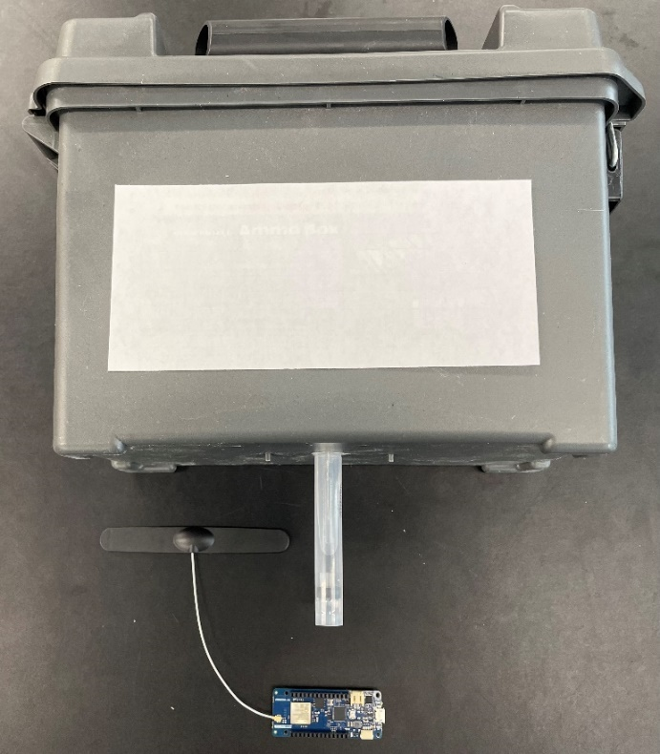 second ARDUINO MKR 1310 was connected through a serial port to the technician's computer to receive the data. This data can be displayed through the ARDUINO IDE’s serial monitor. Using the serial plotter tool of the ARDUINO IDE, graphs may easily be generated and displayed for quick and convenient demonstration, if desired. The transmitted data came from the storage unit on the MKR device, which will normally be transferred directly to the technician's computer. Once the data is received, it can immediately be exported into a .csv file or imported into Excel for the NYSDEC to analyze.

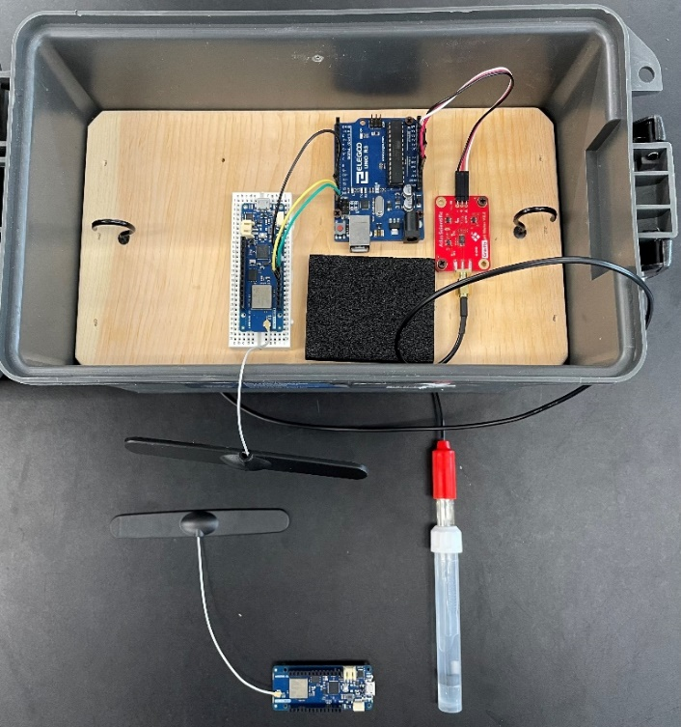

**Figure 7: Field Sensor Unit (FSU) & Receiving Unit**

**Figure 6: Enclosed FSU with Receiving Unit**

**Figure 8: Implementation of FSU in Soil**

**f. Bill of Materials**

The Bill of Materials, which portrays the parts used, their quantity, and their cost, is listed below:

|  |  |  |  |
| --- | --- | --- | --- |
| ***ID*** | ***DESCRIPTION*** | ***QUANTITY*** | ***COST*** |
| ***1*** | Gravity™ Analog pH Kit | 1 | $85.85 |
| ***2*** | Arduino MKR 1310 | 2 | $ 100.14 |
| ***3*** | Arduino R3 UNO | 1 | $34.99 |
| ***4*** | Dipole Antenna | 1 | $5.99 |
| ***5*** | Housing | 1 | $9.99 |
| Total | | 6 | $236.96 |

**Table 2: Bill of Materials of The Project**

**5. Semester Planning**

**a. Gannt Chart**

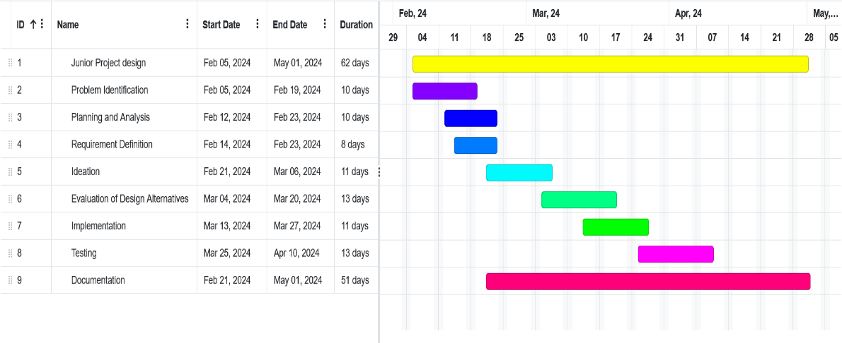The Gannt Chart below illustrates the major tasks required such as design, implement, test and document etc.

**Figure 9: Gannt Chart of the Overall Design & Process**

**Conclusion**

The Microclimate Monitoring System was a significant step towards enhancing our understanding of how to help in the study of regional changes throughout New York state. Our study focused on the collection of pH levels in the soil and working out how to store and transmit the data to a receiver and, finally, to the stakeholder. We implemented our FSU with a Gravity pH Sensor and MKR boards, along with the Arduino R3, to accomplish this task and learn along the way how to design, debug, and work together as a team in a simulated stakeholder environment.

Throughout this project we followed the design process in which we developed our logical and wireframe designs and then transformed these into our actual physical implementation of the design. We considered the low power source (an independent subsystem), the obstacles to collecting data in remote locations, and the challenges that come with trying to receive the data in a prompt and cost-effective manner.

Looking ahead we feel that we made substantial progress in developing and designing a system that could be built at a low enough cost that the NYSDEC could set up enough monitors across the state to get accurate microclimate soil readings. Our design of measuring the pH levels of the soil will be easily replicated in any area of the state, and with the ability to access the LoRa network, the system could be expanded outside of New York state to include more collection and testing.

**Citations**

1. [Soil Phenomena as Evidence of Climatic Changes | Published in American Journal of Science (ajsonline.org)](https://ajsonline.org/article/58124)
2. [Researchers create global map of soil pH and illuminate how it changes between wet and dry climates (phys.org)](https://phys.org/news/2016-12-global-soil-ph-illuminate-climates.html)